Village Sign on the Knoll

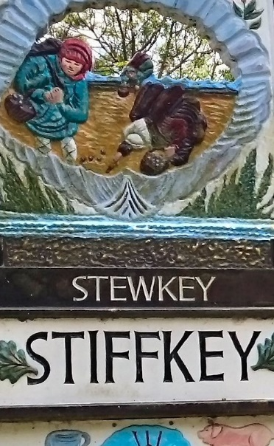
STIFFKEY
A – Z SERVICES and FACILITIES

Allotments
There is a small allotment site behind Camping Hills, which is run by the Parish Council. There are 7 allotments on the site. There are no allotments free at the present time, but 1 allotment will be coming free in October. If you would like to register an interest in the plot please contact the Parish Clerk StiffkeyPC@outlook.com or you can complete the Comment Form on our website.
Stiffkey Allotments have recently benefited from funding from the BIG Society Fund. The grant will provide a communal shed on the site and fencing.

Bottle Bank and Recycling
There is a bottle bank near to the Camp site on Greenway. Proceeds from this go to St Johns Parish Church. The green wheelie bin provided to householders takes recycling, including glass.

Bus Services
The Coast Hopper service, run by Stagecoach, comes through the village. Tel 08712002233 www.travelline.info or you can text nfodtwpa to 84268 for bus times. The bus goes to Cromer (east). There are three Stiffkey stops. One is at the top of Greenway, another on the opposite side of the road to the Post Office and Stores, and also at Campinghills.

Church
The Parish Church is the St. Johns. It is part of the Stiffkey and Bale benefice. There are 8 parishes in this benefice - Morston, Langham, Binham, Saxlingham, Field Dalling, Bale, Sharrington and Stiffkey. Church Services are advertised on a notice just outside the gate.
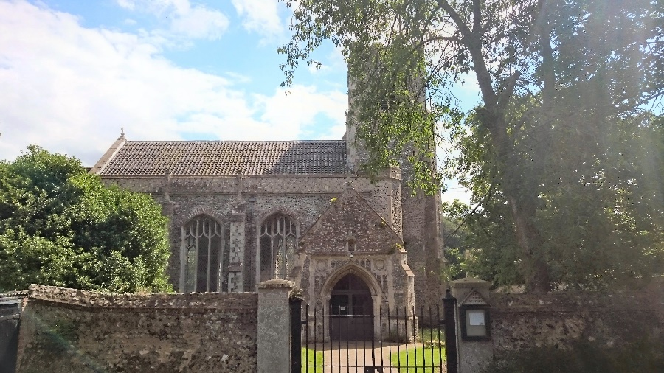 The Church of St Johns, Stiffkey

Dog Waste Bins
These are situated along Greenway and also near to the entrance to the Bangay footpath which starts near Camping Hills. Note that householders can put their dog waste into their black household wheelie bins.

Footpaths
There is a public footpath known as the “Bangay” footpath which is adjacent to Camping Hills. It starts near to the A129 and continues north coming out at the National Trust salt marshes, where it links with the Norfolk Coastal Path. Walk west for about 300 metres and then take a left uphill turn towards the Camp site and along Hollow Lane and back to the A129, or cross back over the playing field and back onto the Bangay. If you continue on the Coastal Path itself, it goes to Morston and Blakeney towards the east and to the west Warham and Wells-Next-The-Sea.
There are other footpaths marked in the village.

Maritime Heritage Centre
This is at High Sands Creek Campsite, Greenway, NR23 1QF. The Centre explores the world of wooden boats and fishing. It features the restored wooden lifeboat “Lucy Lavers”. “Lucy Lavers” travelled back to Dunkirk in 2015. The Centre also features the life of the World War II soldiers at Stiffkey camp and explains the intrigue of the Stiffkey whirligig which lies along the marshland from the campsite. The Centre is open March – the end of October, weekends and bank holidays 10.00 a.m. – 4.00 p.m. Admission is free. www.rescuewoodenboats.com.

Playing Field
There is a playing field on Hollow Lane. The field is used by the Stiffkey Cricket Club. There is also some childrens’ play equipment (to be installed late 2016). This project has been support by the BIG Society Fund.
Pub
The Red Lion on Wells Road, Stiffkey also has eco friendly hotel accommodation and serves local specialities on its menu. Tel 01328 830552 e mail redlion@stiffkey.com www.stiffkey.com

Shops
Stiffkey Stores and Post Office is on Wells Road. As a store is open 8.00 – 5.00 every day. There is a red letter box outside the Store. Letters are collected by Royal Mail from the box during the week at 4.30 p.m. and on a Saturday at 9.00 a.m.

Village Hall
Stiffkey has a village hall built by villagers in the 1980’s. It has a large meeting room, bar and a snooker room. The Parish Council meets at the hall. If you would like to use the hall, contact the Chairman of the Village Hall Committee i.curtis@ymail.com Tel 07787394088

