SAM2 and SPEEDWATCH in STIFFKEY
Prompted by local concerns about speeding in our parish, particularly the outer areas of the parish, several volunteers set up a Community Speedwatch Scheme. This was followed by a successful grant application to Norfolk County Council under their Parish Partnership 50% Funding for local projects. Stiffkey Parish Council was then overwhelmed, following its public appeal for donations to match the grant. Within 6 weeks the Parish Council had received pledges to match fund the project.
The SAM2 Flashing sign was bought in November 2015 from Westcotec, a company based in Dereham. It has to be moved every 4 weeks by volunteers and it records the number of vehicles on the road and the speed and time they are travelling. It also flashes up the speed to the drivers. The information collected is helpful for the police and traffic control. The sites where you will find SAM2 are at the Knoll on Church Street (where it is reversed), near to the Stiffkey Red Lion and in Bridge Street.

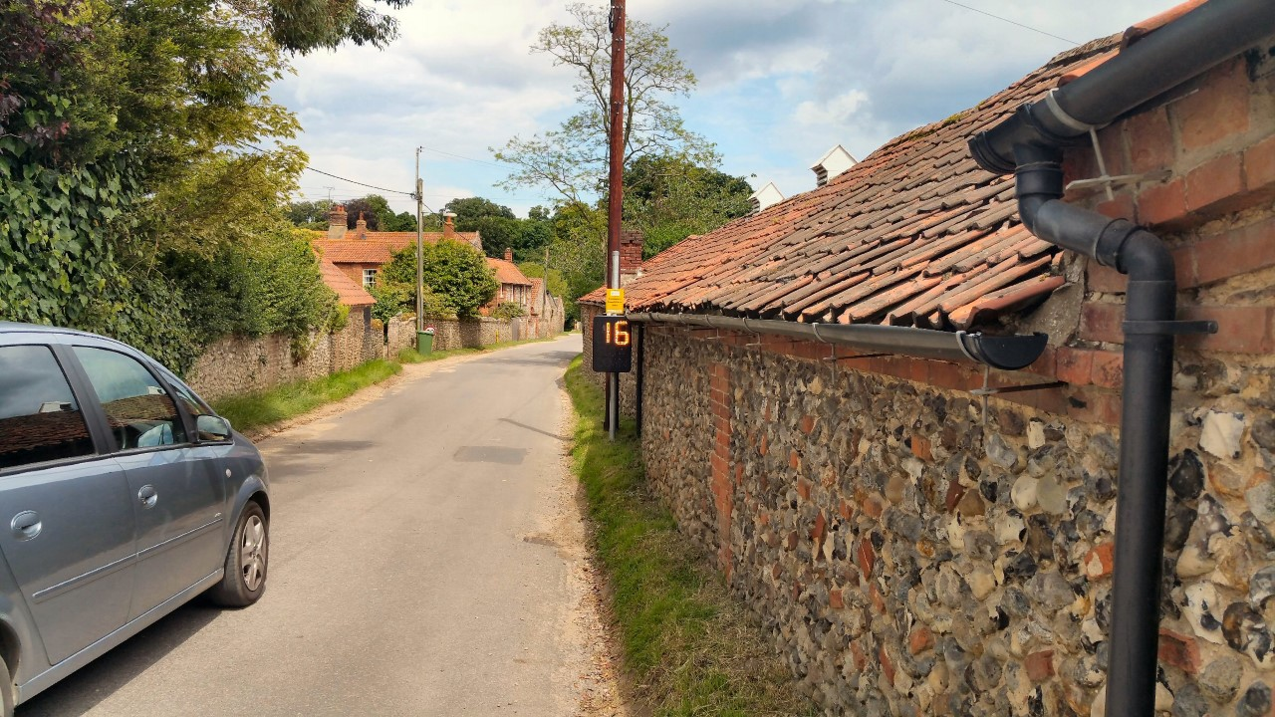
Photo of the SAM2 in action in Bridge Street. The sign flashes to the driver their speed. The computer within the sign also records the number of vehicles, the time they were recorded and their speed

SAM2 and the Community Speedwatch Scheme urgently need more volunteers. If you can spare an hour or two even once a month that would be great. Please contact the Parish Clerk on StiffkeyPC@outlook.com. You can also fill in the Contact Form on our Website, or speak to a Parish Councillor.

